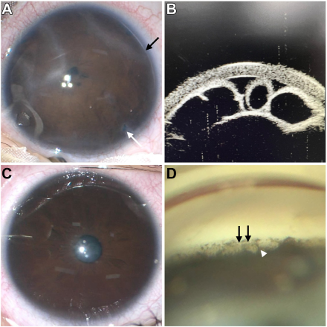

A 3-month-old girl presented with a whitish opacity in her right eye (OD). Examination revealed an abnormal iris morphology OD. Shehad a posterior embryotoxon (PE; A, black arrow), along with peripheral iris atrophy and holes (A, white arrow). On ultrasound biomicroscopy, multiple loculated cysts could be observed OD (B). Her left eye had a grossly normal iris morphology (C), although ongonioscopy a well-defined PE (D, black arrows), with high iris processes were observed (D, white arrowhead). Based on the provided images and clinical description please make an ophthalmic diagnosis for this patient. And output the diagnostic conclusions only.

**The ophthalmic diagnosis for this patient is Axenfeld-Rieger malformation.**